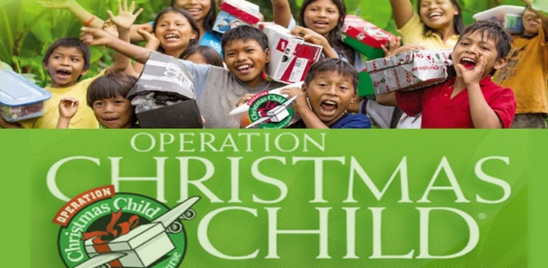

Harmony Road Baptist Church is excited to partner with Samaritan’s Purse as the Durham Collection Centre for the Operation Christmas Child Shoebox distribution and collection this year. The boxes are in! You may drop by anytime during office hours to pick up your empty boxes and instructional inserts. Once filled, you may return your boxes to HRBC. The collection schedule for the completed boxes is below. We have added a second collection week to make it easier for you to return your boxes. Remember to include in each box a $12 or more donation to Samaritan’s Purse Canada, or complete your donation online at https://secure.samaritanspurse.ca/Donationclassic/brochure/
May God continue to reach and bless children and families around the world through Jesus Christ, His Son and Our Saviour and Lord!

Harmony Road Baptist Church

Durham Collection Centre

226 Harmony Road S.
Oshawa, Ontario L1H 6T7
Contact: Pastor Dave Stewart
905-728-2322
pdave.harmonychurch@rogers.com

Drop Off Schedule

Pre-collection Week
November 10-14, Mon.-Fri., 9:00am-3:00pm

Collection Week
November 17 9:00am-3:00pm
November 18 9:00am-3:00pm
November 19 9:00am-3:00pm
November 20 9:00am-3:00pm; 5:00pm-9:00pm
November 21 9:00am-3:00pm; 5:00pm-9:00pm
Church Drop Offs on Nov. 22 and Nov 23. Call ahead to schedule time.


“Engaging our family, our community and the world with God’s Word, in God’s love”

