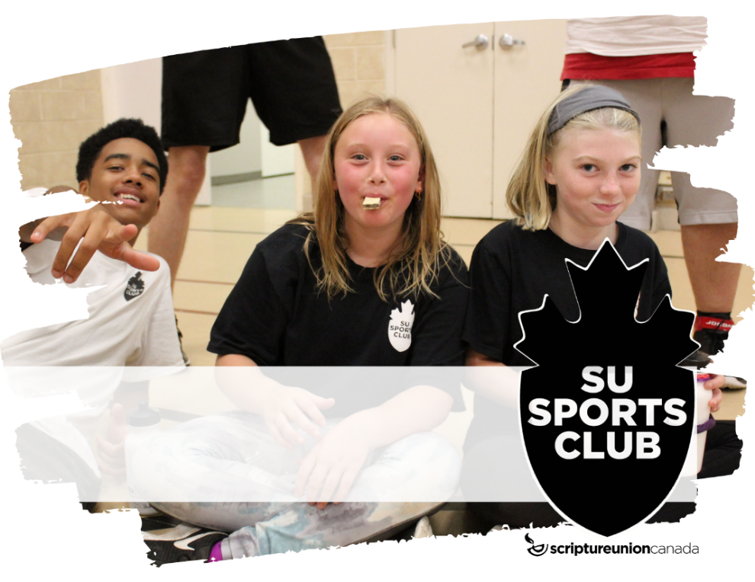
Harmony Sports Club
Harmony Sports Club
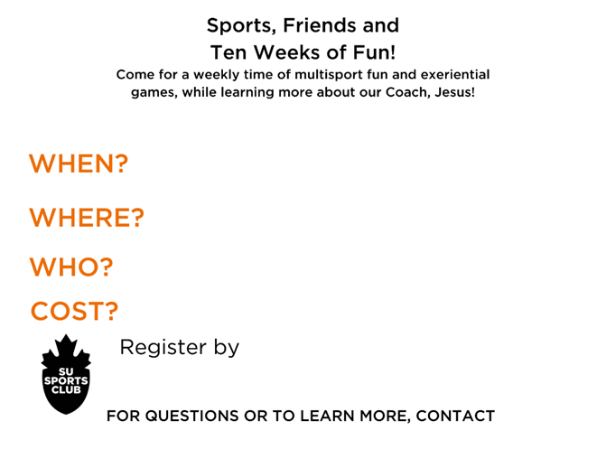
Tuesdays, 6:30-8:00 pm,
October 3 – December 5, 2023
Ages 6-12
$50 (subsidies available)
Church office at 905 728-2322 or
online @ susports.ca/harmony
Pastor Dave Stewart or our church office at 905 728-2322
Harmony Road Baptist Church 226 Harmony Rd. S., Oshawa
HARMONY
SPORTS CLUB REGISTRATION

Child Name: _______________________________________ Gender:________________

Date of Birth: ________________ T-Shirt Size (please circle): YS YM YL AS AM AL
mm/dd/yyyy

Parent/ Guardian Name(s):_________________________________________________________

Address:________________________________________________________________________ Street # Street Name Postal Code

Home Phone Number: ___________________________ Cell:__________________________

Email: _______________________________________________

I acknowledge and understand there are risks involved with my child’s participation in the Sports Club activities, including the risk of physical injury, sickness (i.e. COVID-19, etc…) or damage to personal property and I release Scripture Union Canada, the host church/organization (Harmony Road Baptist Church, Oshawa, Ontario), and all Sports Club staff and volunteers from liability. I understand that photographs and video recordings may be taken by SU which may be used in publications or promotions and I consent to SU using the images for all stated purposes. If you have a concern, please speak with the Sports Club coordinator before Sports Club and arrangements will be made.

Parent/Guardian Signature _______________________________ Date________________

PAYMENT

Amount: ___________________________________

Please make cheques payable to Harmony Road Baptist Church with “Sports Club” on the memo line.

How did you hear about Sports Club? ____________________________________________________

Comments : _______________________________________________________________

Harmony Road Baptist Church
SPORTS CLUB HEALTH FORM

Child Name: _______________________________________ Gender: ________________

Date of Birth: ________________ Health Card #: ________________________________
mm/dd/yyyy

EMERGENCY CONTACT INFO

Name: __________________________________ Relationship to Child: ____________________

Home Phone: ________________ Work Phone:_________________Cell Phone: _______________

MEDICAL INFO

Please list any allergies that your child may have:________________________________________________

________________________________________________________________________________________________

Please list any health conditions Sports Club staff need to be aware of: ________________________________________________________________________________________________________________________________________________________________________________________________
* Note: Any child exhibiting COVID-19 symptoms will be asked to return home and not return until cleared by public health

Please list any medications that your child is currently taking: ___________________________________

_______________________________________________________________________________________________
Important Note: If your child requires medication while at Sports Club we ask that you make arrangements to administer the medicine throughout the day. We will not administer any medicine of any type for children at Sports Club.

Are there any other problems that may affect your child’s ability to participate in Sports Club activities?
_______________________________________________________________________________________________
DISCLAIMER
I am the legal guardian of the child with full authority to make decisions with respect to the care, upbringing, and education of the applicant.
I agree that all of the medical information provided on this form is true and accurate – lacking nothing. I hereby release my child to the care and medical discretion of the staff at Scripture Union, host church/organization and its volunteers. In the event of an emergency and that no one can be immediately contacted, my child will be taken to the hospital or a physician to be treated if deemed necessary by one of the Sports Club staff, church staff or volunteers. I hereby authorize the physician and nursing staff to undertake examination, investigation and necessary treatment of my child.

Parent/Guardian Signature_______________________________ Date__________________

Children with special needs should visit www.scriptureunion.ca/everykidSports Club for more information re:medication.

PHOTO RELEASE FORM

I _________________________ grant permission for Harmony Road Baptist Church and Scripture Union to use photographs and/or video of my child(ren), _________________________________, in future promotion of SU Sports Club and SU Sports Camp. Photos of your child(ren) will not be posted to social media.

(Signature of Adult, or Guardian of Children under age 18)

Name
Address

Phone (day) (evening)
Email Address (optional)

Thank you!

